Detail Design
Textfyre, Inc
Copyright © 2007 – All Rights Reserved
World: Orphan
Series: Orphan, Princess, and Queen
Episode: Orphan

Team:
Original Design: David Cornelson
Writers: Michael Gentry
Programmers: David Cornelson
First Draft Testers:
Alpha Testers:
Beta Testers:
Finalization Testers:
Editors: Fahmida Cater, Bob Feest, Bill Kolomyjec
Graphic Artist:
Flash Artist:
Modification History
Who | When | What
David Cornelson | 30-Nov-2006 | Original Outline Draft
David Cornelson | 21-Dec-2006 | Cleaned up per Mike Gentry’s comments
David Cornelson | 02-Jan-2007 | Detailed world elements
David Cornelson | 04-Jan-2007 | Updated Synopsis
David Cornelson | 10-Feb-2007 | First Draft of Scene I
David Cornelson | 14-Feb-2007 | Scene II Design – Commerce Street
David Cornelson | 17-Feb-2007 | Finalized synopsis and added outline headings. Added Chapter II design. Started Chapter III.
David Cornelson | 7-Mar-2007 | Incorporated Chapter I from Mike Gentry’s submission. Added maps for all chapters.

Table of Contents
Map of Miradan 8
The World of Orphan 9
The People 9
Ascension 9
Magic 9
In People 9
In Things 10
Physics 10
Astronomy 10
Recent History 10
Before The Story Begins… 12
Royalty Reference 13
The Players 14
The Player Character 14
Jacqueline Toresal (aka Jack) 14
Major Non-Playing Characters 14
Bobby 14
Baron Fossville (aka The Baron, Fossville, the Dark Hunter) 14
Mercenaries (group of men) 14
Hester Rodop (aka the Magistrate) 14
Jacobs 14
Olmer 14
Darens 14
Other Major Characters 15
Duke William Toresal (aka Lord of the Keep, the Old Lord, the Prince, the Queen’s Son) 15
Minor Non-Playing Characters 15
Teisha 15
Angeline, Clara, Fiona, Theresa, Shannon (Maiden House) 15
Old man Holstenoffer (In Butchery) 15
Olgan Minor (Armory) 15
Mrs. Sandler (Jewelry) 15
Pieter (Jewelry) 15
Rudolph (Jewelry) 15
Chorus Brothers 16
The Screenplay 17
SYNOPSIS 17
Game Features 19
Time Keeping 19
Details 20
Chapter I – Grubber’s Market 20
Map 20
Rundown 20
Notes 21
Design 21
Chapter II – Commerce Street and Bobby 36
Map 36
Rundown 36
Notes 36
Design 37
Chapter III – Bobby 40
Map 40
Rundown 41
Notes 41
Design 41
Chapter IV – Maiden House 42
Map 42
Rundown 42
Notes 42
Design 42
Chapter V – Captured 43
Map 43
Rundown 43
Notes 43
Design 43
Chapter VI – Underground 44
Map 44
Rundown 44
Notes 44
Design 44
Chapter VII – Black Gate Estate 45
Map I - Rooftops 45
Map II – Black Gate Estate 45
Rundown 45
Notes 45
Design 45
Chapter VIII – Maiden House II 46
Map 46
Rundown 46
Notes 46
Design 46
Chapter IX – Red Gate Estate 47
Map 47
Rundown 47
Notes 47
Design 47
Chapter X – Pieter 48
Map 48
Rundown 49
Notes 49
Design 49
Chapter XI – Mercenaries 50
Map 50
Rundown 50
Notes 50
Design 50
Chapter XII – The Baron 51
Map 51
Rundown 51
Notes 51
Design 51
Chapter XIII – The War Room 52
Map 52
Rundown 52
Notes 52
Design 52
Chapter VIX – The Princess 53
Map 53
Rundown 53
Notes 53
Design 53

Map of Miradan
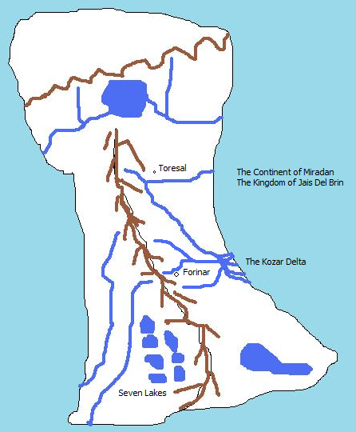

The World of Orphan
In this world there exists a single planet where humans live and magic is extremely rare. The world has large bodies of water and at least one land mass as of this history. This continent is known as Miradan and is loosely ruled by the Kingdom of Jais Del Brin.

The People
The people of Jais Del Brin are generally farmers, fisherman, and townspeople. Commerce is rugged and local, and the Kingdom generally functions without much taxation. Royalty includes the King and Queen, Princes, Princesses, Dukes and Duchesses, Earls and Countess, Barons and Baronesses.

Ascension
The Kingdom generally selects new Kings based bloodlines, but this is married to the fact that the vast majority of Kings have sired strong, popular, and healthy sons to ascend to the throne. The key here is popularity. The Kingdom has rarely had to think about succession and when it has, it has generally been between two strong choices, not a complete lack of strong choices.
In the absence of a strong and popular blood prince, the laws of the Kingdom state that the King or Queen must choose a successor. In the event of the death of the King and the Queen before a successor has been named, all of the primary royals will select a Regent to handle Kingdom affairs until a successor is selected by vote. Voting is weighted in that Princes and Princesses get ten votes, Dukes and Duchesses get five votes, Earls and Countesses get three votes, and Barons and Baronesses get a single vote. But again, the general public’s opinion is taken into consideration before a successor is selected. A special People’s Regent role has always been filled, but never used but for ceremony. The role in the case of an unclear successor is to poll the people and make known their wishes. Obviously, in certain circumstances, this could become a very dangerous and powerful role.

Magic

In People
Magic is known to exist and is treated respectfully by the general population. They consider it either lucky or unlucky to have good or bad things happen due to magic respectively. Everyone always dreams of some minor magic to help their daily lives, but almost no one goes in search of it. Life is hard and there is no time for such endeavors. Those people that have discovered a talent for magic generally keep it to themselves and help or hurt those as they would with any other talent. There is no general commerce in magic, but if a magic user is available, some may intrude to ask for a favor and offer some token in return. Magic tends to develop in women more than men, although an analysis of those with “talent” would show that girls are encouraged to look within and boys are not, so never develop whatever ability they may have. Girls with talent are considered blessed or cursed, depending upon their nature (if a girl is a trouble-maker, she’s cursed…if a girl is kind, she is considered blessed).
Most magic is minor. Very little “grand magic” is know about or has ever been seen. The common uses of magic are to mend clothes, cure minor ailments, fix broken tools, and the like. On occasion a magic user will have more interesting abilities.

In Things
There are artifacts that are imbued with magical ability, giving the owner of the artifact some magical ability, albeit focused and limited.

Physics
The general physics of this world are the same as Earth.

Astronomy
The night sky of this world is full of stars. One section of the sky that is seen in summer is a strip of very bright stars known commonly as “The River of Light”. It also has two moons, one noticeably large than the other. They are known commonly as Big Sister and Little Brother.

Recent History
The Realtic Kingdom has been seemingly healthy for hundreds of years, with successions going without any problem. But the last two kings have ruled poorly and the most recent king has left the land to an elderly queen, who only late in life realized she would need to rule and determine a successor. Although her children and grandchildren may vie for the crown, their particular fates have produced a great deal of concern from the public and the Lord’s council as to their ability to rule.
Succession rights are simple where blood is concerned, but with so many inline, the fate of the kingdom is not so simply decided. It’s almost a game or a sport. Whoever shows the Queen that they deserve it, and then garners public approval, will become the heir to the throne. Because the Kingdom has had such a peaceful history, the public would balk at a heavy-handed ruler.
Orphan is the story of a young girl that is at the top of the blood lines, along with many other potential successors. Her father was the last son born of the current queen, with seven siblings in front of him. Unfortunately, his fate was decided by Baron Fossville. Having seen the coming turmoil, he wished to vie for the thrown himself, and turned to dark means to attain it.
In the 756th year of the Kingdom, Baron Fossville managed to slowly poison Duke Toresal, making it look like a mysterious illness. What Fossville did not know until taking over the Duke’s keep and lands was that the former Lord had bore a child with a woman in secrecy. Since the Duke was already married, the secret remained buried for years. But before his death, Duke Toresal left written claim to all of his estates to his only daughter. He had loved the woman that bore her, but could not openly recognize her or their child…a mandate from the Queen herself, since the woman was not of royal blood.
But his will left the door open for young Jacqueline, and this is her story….

Before The Story Begins…
Your name is Jacqueline, but everyone outside of the Maiden House knows you as Jack. A few people have come to know you well enough to know that you are a girl and some have figured it out on their own. A few suspect that you are special and some think it's because you are the daughter of a royal personage. No one knows for sure. There is proof of the matter within your father’s personal papers and some people in the royal government know. The fact that you exist and there is no other clear heir to the local lands (much less the Kingdom’s throne) is the intrigue into which you were born. If you were to be recognized a royal heir it would cause a great deal of upheaval and if you were not recognized, things would probably progress more smoothly, albeit in a fashion the crown is not comfortable with. It would elevate a family that is highly ambitious, placing their heirs in a position to marry into the throne.

Your sponsor has in fact been your father by blood. He loved the woman that bore you to him, but as a mistress, there was no way to bring her or you to court. For the first ten years of your life, your father watched as you grew. He made sure that some of the women in Maiden House were well-educated and paid them to tutor you.

In your eleventh year, Lord Duke Toresal died of a mysterious illness. He left a legacy of goodwill among the people, but the succession to his lands was clearly going to Baron Fossville, a man who hired mercenaries for mysterious businesses and who had clear ambitions for the royal court. Fossville’s machinations were coming to fruition as a royal ball was planned at which he would be betrothed to one of the Queen’s daughters.

You are a fourteen year old girl on the verge of becoming a woman. Your mother died when you were born and you do not know who your father was. You do know that someone sponsored your early upbringing at Maiden House. Even though they care for you and feed you, and even though you do appreciate everything they did, you always felt you were destined for something else. You learned to read and write; a great deal of history of the land, to speak and act properly, and how to be respectful. You even were given the gift of a solid self-esteem. You possess all of the things that most orphans never even know about.

Eventually you decide that the stodgy lifestyle of the Maiden House was more than you can bear and you began taking to the streets at the age of eleven, nearly the same time Lord Toresal died. Wearing trousers and a boy’s shirt and continually cutting your hair off with a blade and covering it with a hat, you instinctively realized that certain doors were open to you pretending to be a boy.

The maidens counted it a phase and although they worried if you were out all night, they never questioned where you'd been or what you'd done. It was as if they accepted your maturity and decision making almost entirely without question. But they did look out for you too. More than once you caught one of the younger maidens "accidentally" bumping into you.

For the next three years you manage to befriend other orphans, although of less luck. They happily show you how to beg, steal, and sneak around town without ever getting caught by the magistrate or his soldiers. One of the beggars you befriend is a boy named Bobby, who appeared on the streets shortly after your eleventh birthday. Never questioning the appearance or disappearance of any of the orphans, you don’t realize that he is in fact a spy for the royal court, and in some ways, your protector.

Royalty Reference
- King, Queen
  - Prince, Princess
- Duke, Duchess
  - Prince, Princess (if they have royal parentage)
- Earl, Countess
- Baron, Baroness

The Players

The Player Character

Jacqueline Toresal (aka Jack)
Jacqueline is a fourteen year old girl coming of age in a rugged town on the outskirts of the Kingdom.

Major Non-Playing Characters

Bobby
Bobby is an orphan, sixteen years old, and seems to do things for various people for money, but you can never quite figure out what he does. You don't know where he sleeps, but he always seems "taken care of". Well, sometimes he looks a wreck, but he never seems bothered by it.

Baron Fossville (aka The Baron, Fossville, the Dark Hunter)
Baron Fossville is a nobleman by birth, the son of some cousin of the royal family. He’s been sent on many a mission for the crown to deal with uprisings and skirmishes with the western people. Through these efforts he has gained a formidable following. It is commonly believed that he is maneuvering to marry the eldest daughter of the Queen and become heir to the throne.

Mercenaries (group of men)
The mercenaries are generic men with tunics, pants, swords, helms. They all speak in broken language laced with common slurs. They aren’t very smart either.

Hester Rodop (aka the Magistrate)
The magistrate, Hester Rodop, is a very bad man. He will try very hard to catch you doing something wrong and if he does, it will not go well for you. You could wind up in a cell with bad men.

Jacobs
Jacob’s is the son of a wealthy merchant. He’s a big brutish man. Though he is slightly insane, he will talk about anything to anyone.

Olmer
Olmer is a typical town bum. On some days he’ll work and some days he’ll steal. He’s never seen without Darens.

Darens
Darens is another typical bum. He’s always with Olmer.

Other Major Characters

Duke William Toresal (aka Lord of the Keep, the Old Lord, the Prince, the Queen’s Son)
Lord Toresal ruled the namesake lands for several decades in peace and prosperity. The keep was always open to commoners and the town was built to provide a place for commerce. Everyone seemingly benefited from the prince’s rule, except for Baron Fossville. Toresal kept Fossville at arm’s length for some unknown reason and two were known to have verbal jousts in public.

Minor Non-Playing Characters

Teisha
Teisha is a girl in Grubber’s market that is somewhat of a friend. She teases you about the Maiden House and is somewhat aloof, but she is never mean to you. Although there is no blood relationship, the two of you look somewhat alike, if not a perfect match.

Angeline, Clara, Fiona, Theresa, Shannon (Maiden House)
Angeline, Clara, Fiona, Theresa, and Shannon are the women in the Maiden House. They are all widows that look out for each other. They do various odd jobs for town folk and farmers who pay them in food and bare necessities. They know many things about the town and surrounding area, although they will very rarely offer details without some prior knowledge.

These women are the help system. They will offer information on how to solve problems within the game as you learn about them. So when you find a door you can't unlock (unlikely), they will know how to help you.

Old man Holstenoffer (In Butchery)
The butcher will talk incessantly while you are in his shop. Some of the things he says will give you some clues to puzzles.

Olgan Minor (Armory)
Olgan will talk about Fossville’s recent purchases of armor, as if he plans to build an army.

Mrs. Sandler (Jewelry)
As it turns out, Mrs. Sandler knows who your mother was and liked her. She also is in possession of something that belongs to you; a diamond and ruby necklace.

Pieter (Jewelry)
Pieter is also a spy for the crown, but plays a guard. He knows all about you.

Rudolph (Jewelry)
Rudolph is a simpleton guard, and friend of Pieter’s.

Chorus Brothers
When rumors start floating about your possible inheritance, the Chorus brothers are more than willing to lend you money, considering it an excellent investment.

The Screenplay

SYNOPSIS

A young orphan girl pretending to be a boy discovers people are trying to kill her, that she is royal born, and that she must save herself by finding out as much information as possible, as well as proving that she is worthy of being recognized as the heir to the local lands.

- Jack is chased by mercenaries and does not know why.
- Jack has opportunities to talk to people about the environment.
  - Butcher
  - Baker
  - Armory
  - Moneylender
  - Jeweler
  - Clothier
- Jack meets Bobby and is taken on a wild chase through town and into the woods, escaping into the secret tunnel of Lord’s Keep. They find about the Queen’s visit and the upcoming ball where the Baron will marry into the Royal Family.
- Jack goes back to town to sleep at Maiden House, where the women hide her in a secret room. Here she learns about her mother.
- Jack tries to get back through town to the woods and is captured. Bobby is beaten up badly in an adjacent cell. He whispers about secrets in Black Gate Estate, the in-town residence of Baron Fossville. Jack meets crooks that help her escape and tell her where to hide in the sewer.
- Jack is chased into sewer system and hides.
- Jack comes out of hiding and gets into Black Gate Estate. She finds out about her father, including the letter that recognizes her as heir.
- Jack hears that Bobby has been hung and returns to Maiden House. The women open up about everything and tell her that the Red Gate Estate (previously her father’s residence) is her home now, but dangerous to go there.
- Jack gets into Red Gate Estate with key from maidens and one of the maidens coming with her. She finds artifacts about her father. She also finds fresh clothes and a bath. One of the maidens helps her bath and suggests she buy a new gown and to sneak into the ball to seek audience with the Queen.
- Jack visits the moneylender and with the letter is able to take money out. Jack visits the clothier and jeweler to get ready for ball. Pieter decides to accompany her. Jack visits the armory and buys a stiletto knife and hides it in her bodice.
- Jack and Pieter cannot enter Lord’s Keep directly as the mercenaries are all stalling guard. Jack shows Pieter the secret entrance. On their way through the woods, an odd old woman approaches them. She cryptically offers Jack a potion. The potion makes Jack’s hair grow out. They enter the Keep and filter into the ball room, uninvited. The Queen has not arrived yet.
- The mercenaries start filtering into the Keep. They begin to recognize Jack and Pieter disappears. The Baron appears at Jack’s side and holds her arm tightly. He walks her to the War Room.
- Jack enters the War Room. Pieter is slumped on the floor, bound hand and foot. Several mercenaries glare at Jack menacingly. The Baron has the door guarded and sits down. He asks Jack what you’re doing. Jack shows him the letter. He seems nervous, but confident. The Baron burns the letter in the fireplace and picks up his sword. He approaches. Suddenly there is an argument outside. A fight is heard. The door is knocked down and Bobby comes charging in. He fights a dual with the Baron.
- Jack releases Pieter with your knife. He takes it and begins fighting mercenaries. The Baron knocks Bobby down and runs out of the room. The mercenaries follow, as do Pieter and Bobby. The Princess comes into the room from a secret passage. She has more mercenaries with her and they kidnap Jack.

Game Features

Time Keeping
The setting must have night and day characteristics.

Room locations should note light regarding the sun and moon where appropriate.

Room locations should note crowdedness based on the time of day. For instance, the markets are crowded during the day and empty at night.

We should be able to easily enough implement "wait for darkness" or "wait until morning". This could potentially be an extension.

Details

Chapter I – Grubber’s Market

Map
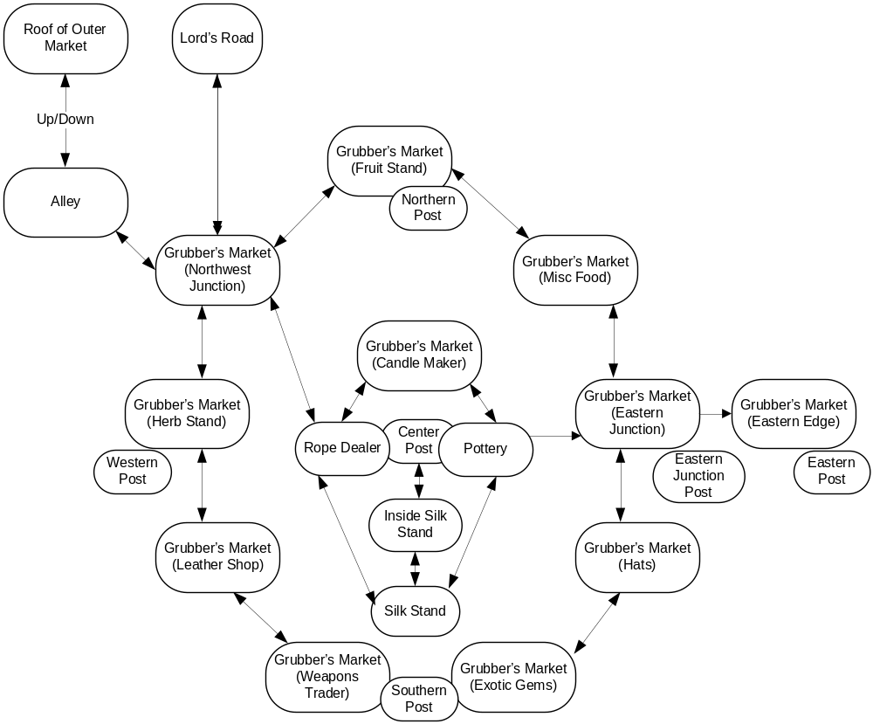

Rundown
You have no money. You are wearing a wool cloak. You have an apple.
You may steal a knife from a mercenary.
You may trade the knife for nearly anything in the market including herbs, fruit, candles, rope, pottery, silk, belt, boots, coin, small gem, or a hat. You will always be able to steal another knife, but never hold more than one at a time.
The monkey wants a banana.
The monkey has a necklace and will trade for a banana.
The monkey runs across the postal wires all the time. If you’re at the Exotic Gems stall, he will come down to its roof and taunt you with the necklace.
Teisha, in the silk stall, will give you a silk cloak for the necklace.
You can get a hat by trading your cloak.
You can get a belt by trading a hat.
You can get fruit with coin.
You can never go east to the Eastern Edge or you will be caught and have to escape back to the west.
You can go up the center post and slide down to any of the outer posts.
When you slide down, the guards will see you. You should not be wearing the cloak yet.
When you go down from the n, w, or s post, you should wear the cloak and undo your hair so that you look like a girl.
Now you can leave the market before the men recognize you.

Notes
- Should the monkey be able to block you from sliding down? If so, how should we get rid of the monkey? This _has_ to be a funny response. I can just feel it.
- If you simply turn into a girl and start walking directly out of the market, the mercenaries at the eastern edge are so loose that they’re pretty much accosting everyone and will catch you. In order to get past them, they must be on edge from seeing you traverse the wire from the center post.

Design
- Before Play Begins: (prologue)
  - Design
Player is walking through market near silk stall. She says “Hi” to Teisha, noticing silk cloaks she can’t afford. She walks to fruit stall and buys an apple. She stops in the alley to eat the apple.
  - Actual
Mid-morning always sees the Grubber's Market at its most crowded. Servants from the aristocratic districts and villagers from outside Toresal crush themselves into the maze of stalls and stretched canvas, hoping to beat the noontime heat and get the farmers' produce while it's still fresh. The press of bodies, the din of haggling and bargains struck – it all makes getting around unnoticed easier, although not necessarily more pleasant. No fewer than half a dozen stall-gazing bumpkins have trod on your feet already this morning. You've kept your mouth shut, though. People remember an urchin who gives lip.
"See anything you like?" asks the woman at the silk stall, with a teasing smile. You smile back. You couldn't afford the cheapest of her cloaks if you nicked ten purses in a morning, as Teisha well knows.
"Oh, these are much too plain," you scoff, even as you gaze wistfully at the bright colors, the beautiful embroidery. Time for a bit of breakfast, you decide, and anyway if you linger too long, people will wonder what a boy is doing shopping for women's cloaks. "Perhaps I'll come back this afternoon, when you've put out your better wares."
Teisha laughs. "Don't be a stranger, Jack."
You make your way through the market, nicking an apple from the fruit stall while its owner haggles with some fat outlander over a bushel of kello fruit, until you reach a quiet alley where you can catch a breath from the crowds and enjoy your breakfast in peace. All in all, just another ordinary day at Grubber's Market.
But the first bite is barely in your mouth before you hear rough voices at the alley's entrance, and in a moment your life is turned upside-down.
- When Play Begins:
  - Design
The Player is named Jack or Jacqueline Toresal. She looks like a boy, but is a girl.
  - Actual
Most people know you as "Jack," a fourteen-year-old street urchin of uncertain means. You are slight of build for a boy your age, though your baggy clothes hide much of your physique. Your hair is ragged and short, a victim of many self-inflicted trimmings. Though usually in need of a good scrubbing, you are an attractive youth, with a softness to your face that makes you seem younger than your years.
Fortunately, it also leads people to underestimate your wiles and resourcefulness, which has caused more than one stall keeper to call you by your second most common sobriquet, "That Damn Thief!"
- Only a few people know you by your real name, and you are pleased to keep it that way.
  - Jack is sitting in an alley about to eat an apple. She hears loudly talking men walking towards her from the north. The men will arrive in the alley in several turns.
  - The player is carrying:
    - Object: Apple.
      - Description: Round, taut, green at the bottom shading up to red near the stem.
      - Eating or tasting while the soldiers are in the marketplace: No time for breakfast right now!
      - Eating or tasting after the first scene: Crisp and delicious!
    - Object: Cloak. (wool, masculine)
      - Description: Your cloak is made of un-dyed wool, stained and patched in several places. You wear it in the masculine style, buckled to the side and thrown back over your right shoulder.
    - Object: Satchel (cloth).
      - Description: Your trusty cloth satchel: big enough to hold the things you nick, small enough to not hamper your getaway.
- Prologue – Alley
  - Description (day): This narrow alley is tucked away between a wooden storehouse on one side and the canvas wall of a stall keeper's tent on the other. It serves primarily as somewhere out-of-the-way for stall keepers to sweep their garbage into, so it's not exactly the most pleasant-smelling place in all of Miradan, but at least no one is likely to bother you here. You can leave to the southwest.
  - Description (night): The shadows in the alley are nearly impenetrable at night. You can barely see your way in the gloom.
  - Object: Crates. (piled up, empty, immovable)
    - Initial Appearance: Several crates are stacked up against the back wall of the alley.
    - Description: Just ordinary wooden crates, used by merchants throughout Miradan to store and ship goods. There are scores more just like these to be found all over the market.
    - Taking or pushing: Oof! What's in these things, gold bricks? At any rate, the crates are far too heavy for you to move.
    - Opening or Searching : The crates are all nailed shut.
    - Climbing on: You nimbly hop up on top of the crates; from there, it's only a short scramble to the roof of the market.
  - Command: listen to men [men are loud, but their conversation is not discernable]
  - Command: pick up crate [too heavy]
  - Command: climb crates or go up [player moves to roof of outer market]
  - Command: wait [men get closer-louder, after several turns, men will arrive]
  - Command: north [men appear and grab you before you can leave alley]
  - Command: southeast [player moves to Northwest Junction of Grubber’s Market]

NOTE: Grubber’s Market at night is a single large empty location. You can traverse northwest to the alley, north to Lord’s Road, or East to Commerce Street. During the day it has the following mapped layout:

- Grubber’s Market – Mercenaries
  - There are a random number of mercenaries actually chasing you. There is a group of them on Lord’s Road and at the Eastern Edge.
  - You generally are able to slip past them, but they grab you once in awhile. You can kick, bite, scratch, claw, punch, hit, or spit at them to escape.
  - When you are in the arms of the mercenaries, one of the men will drop a knife. You may pick this up before escaping. Only one knife can be held at a time.
  - You will always have time to look around and do business at a stall. But they will constantly be grabbing you and the frequency of this should increase to give of the feeling of them “closing in”.
  - Eventually they catch you and the game has to end. There’s just no way to get around the fact that you have to solve this puzzle.
  - Commands: (need text responses)
    - Kick:
    - Bite:
    - Scratch:
    - Claw:
    - Punch:
    - Hit:
    - Spit At:
    - Scream:
- Grubber’s Market – Northwest Junction
  - Description: This is the northwest corner of Grubber's Market. You can skirt around the edge of the market to the northeast or south, or head into the center of the market to the southeast. A wide, paved road leads north, towards Lord's Keep. You can also duck back into the alley to the northwest.
- Grubber’s Market – Fruit Stall
  - Description: Bins heaped high with bright-colored fruit lend a pleasant fragrance to this end of the market (though by afternoon it will have become a cloying reek that attracts more flies than customers). Aisles between the stalls lead southwest and southeast.
  - Command: [trade knife for banana]
  - Object: Bins/Fruit (collectively).
    - Description: Mostly domestic, apples and pears from the city orchards, or brambleberries from the northern counties. A few of the baskets contain more exotic fare: oranges, limes, and kello fruit – even a bushel of bananas from the Kozar Delta.
    - Kello Fruit: Normally you'd kill for a slice of kello, but these look a bit too green. Not quite in season.
    - Bananas: You rarely see bananas this far north. These look just about perfect – plump, bright yellow with just a sprinkling of brown freckles.
- Grubber’s Market – Miscellaneous Food
  - Description: Baskets bristling with loaves of bread; yellow pyramids of cheese; spiced jerky hanging in bundles overhead – a typical grocer's stall. You can continue along the market's outer ring to the northwest or south.
- Grubber’s Market – Eastern Junction
  - Description: You're near the eastern edge of Grubber's Market. You can travel along the outer ring of stalls to the north or south, or head towards the market's central hub to the west.
- Grubber’s Market – Hat Stall
  - Description: Hats of all styles and sizes hang from scores of wooden pegs, surrounding the stall itself in forest of varied headgear. More stalls lie to the north and southwest.
    - Object: Hats (collectively)
      - Description: If you can wear it on your head, it's sold here. Big, flop-brimmed traveling hats; small, leather workman's caps; wide sappans of woven straw from the Kozar delta; fancy, feathered hats for courtly balls; and even a few ordinary bonnets.
  - Command: [trade cloak for hat] (note: since you already have a hat, this might be another interesting moment for humor. Maybe some confusion with the seller)
- Grubber’s Market - Exotic Gems Stall
  - Description: The shelves of this stall are lined with black velvet cloth, across which are spread dozens of jewels in exotic colors and cuts, all glittering in the dusty sunlight..Other stalls lie to the west and northeast.
  - Object: Gems (collectively)
    - Description: Some of them are loose stones; others are set in finely wrought rings and necklaces. Most of them were probably illegally smuggled from over the western mountains, which is why they're cheap enough to be affordable by anyone in Grubber's Market. Still, they're far, far out of your price range.
  - NPC: Monkey
    - Description: (First time)
Suddenly you hear a commotion from the back of the stall: the crash of a display case hitting the ground; shouts and curses from the stall keeper; and a horrific, gibbering shriek.
"Come back here, you flea-bitten thief!" yells the stall keeper, and for a panicked moment you think he means you. Then you see something small and gray dart up to the roof of the stall… it's just a forest monkey, probably someone's pet running loose. And it's clutching one of the stall keeper's necklaces in its tiny black fist.
The monkey turns and screeches back at the stall keeper, dodges a clumsily thrown dirt clod, and scampers up the nearby support pole.
  - Initial appearance (up on the pole): The monkey is here, bouncing up and down on the wire a few feet away.
  - Description: It has silvery fur and black mask-like markings on its startlingly human face. It seems to regard you with a mixture of curiosity and amusement – as though you were some strange little animal whose antics it found entertaining. [if it has the necklace] It grips the necklace protectively, tight against its tiny chest.
  - If you are holding the banana: The monkey sniffs the air excitedly as you come closer, and emits a hopeful chirp.
  - Command: [Taking the necklace from the monkey]
The monkey screeches at you and backs away.
Note: I’d like a few more descriptions for this. We’ll play them randomly.
  - Command: [Trading the banana for the necklace/giving banana to the monkey]
Chattering with glee, the monkey lunges for the banana. In its haste, the necklace slips from its grasp – and you barely manage to snatch it up before it falls to the market below.
The monkey, meanwhile, tears the banana peel open and scarfs down the soft white fruit in a matter of moments, after which it saunters off down the wire, hooting contentedly.
  - Object: Necklace
    - Description: It's a beautiful gem, clear blue with a deep indigo star in its center, set in a silver-wrought starburst on a silver chain. You could easily trade it for any piece of merchandise in the market. Or you could… you know… wear it.
- Grubber’s Market - Weapons Trader Stall
  - Description: The weaponsmith's wares hang from wooden racks along the sides of this stall, a grim picket fence of down-hanging blades. You can find less intimidating stalls to the east and northwest.
  - Object: Weapons, Swords, Knives (collectively)
    - Description: and knives, mostly. Nothing fancy; just sharp, practical, and deadly.
  - Command: [trade knife for coin] player receives one coin, good for purchasing fruit, rope, candle, herbs, or food.
- Grubber’s Market – Leather Shop
  - Description: You pause here for a few deep breaths – you've always enjoyed the smell around the leather merchant's stall. More stalls lie to the north and southeast.
  - Command: [smell anything]
The smell of leather reminds always makes you think of long traveling in dangerous lands. It's the smell of adventure.
  - Object: Leather goods (collectively)
    - Description: This merchant deals in riding equipment – reins, harnesses, stirrups, and the like. A full riding saddle sits on proud display near the back. There are a few items of clothing for sale as well, mostly various styles of scabbards and belts.
  - Command: [trade hat for belt]
- Grubber’s Market – Herb Stall
  - Description: The herb stall is usually a quieter place. Customers like to browse, poke their noses into the various jars and pouches, and judge the potency of a potential purchase at their leisure. You've never understood the fascination, yourself. More interesting stalls are to the south, and the market opens out a little to the north.
  - Object: Herbs (collectively)
    - Description: The herb stall is usually a quieter place. Customers like to browse, poke their noses into the various jars and pouches, and judge the potency of a potential purchase at their leisure. You've never understood the fascination, yourself. More interesting stalls are to the south, and the market opens out a little to the north.
  - Object: Support Post
    - Initial Appearance: Next to the herb stall stands a thick wooden post.
    - Description: It's one of several posts that support the large canvas awnings stretched above the market square. You can see one of the main support wires running from the top of this post to the top of the high post rising up from the center of the market.
  - Command: [climb post]
You could shimmy up there easily enough, but it would attract too much attention.
- Grubber’s Market – Candle Maker Stall
  - Description: The heat and fumes from the candle maker's tallow pots make this stall an unpleasant place to loiter. Still, people need candles, and customers seem to be buying them as fast as the stall keeper can dip them. Other stalls are to the southeast and southwest.
  - Object: Candles (collectively)
    - Description: The candles hang in pairs from long wooden dowels, connected to each other by their common wick. Most of them are tallow, fast-burning and cheap, but near the back there are boxes of premade wax candles in different colors.
  - Object: Tallow Pots
    - Description: The candle merchant keeps a pair of small cauldrons at a constant boil, filled with bubbling, yellowing goop.
- Grubber’s Market – Rope Stall
  - Description: One thing you can say about the rope stall: you'll never spend a moment wondering what's for sale. Rope and lots of it, thick and thin, knotted or loose, in heaps and in coils, stacked on the floor or hanging from pegs. More stalls are to the northeast and southeast, and the market opens out a bit to the northwest.
  - Object: Rope
    - Description: Coarse braids of scratchy hemp, stiff and tough.
- Grubber’s Market – Pottery Stall
  - Description: The wares at the pottery stall are spread out on the ground or set on low benches, forcing browsers and passers-by to step carefully around them. There are more stalls to the northwest and southwest, or you can head out to the market's edge to the east.
  - Object: Pottery (collectively)
    - Description: From tall, narrow, precariously balanced urns to round, gourd-like jars to shallow bowls, each is uniquely shaped, yet they all share a common, graceful curve. Most of them are made of fired clay from the Westlands, decorated with colorful glazes.
- Grubber’s Market – Outside Silk Stall
  - Description: Teisha has done well enough for herself that her "stall" is actually a full-on tent. You can enter the tent to the north, or continue on to other stalls to the northeast or northwest.
  - Command: [enter, in] player moves to Inside Silk Stall.
- Grubber’s Market – Inside Silk Stall
  - Description: The fabric walls lend a bit of privacy and quiet from the crowds outside (in addition to keeping dust off the merchandise). Beautiful silk garments hang from racks on either side. The main market lies to the south. A narrow gap in the back leads behind the tent.
  - Object: Garments (collectively)
    - Description: Gowns, robes, capes, cloaks, and shawls – their hems rippling with the slightest movement of air, shimmering with that soft, liquid glow that only silk has. You sigh. Dressing up like a boy is definitely fun, but looking at Teisha's wares always makes you yearn for something a little bit more… elegant.
  - NPC: Teisha
    - Initial Appearance: Teisha sits on a stool in back, smiling distractedly.
    - Description: Teisha is a short, busty woman with a smile as warm as her tumbling red curls. She likes you, and she knows that you'd never nick from her stall, so she lets you hang around the stall and look through the merchandise. She also knows your big secret (guessed it the very first time she caught you loitering at the tent flap), which is a little bit scary and a little bit of a relief – it's nice to be able to let your guard down and talk to someone outside the Maiden's House.
    - Idle Actions: (Randomized)
      - Description: Teisha hums quietly to herself.
      - Description: Teisha smiles at you warmly.
      - Description: Teisha brushes a loose thread from the sleeve of one of her gowns.
      - Description: Teisha toys with her measuring cord, spinning it idly.
  - Action: Entering the tent for the first time:
    - Description: "Hello, Jack," says Teisha. "Change your mind about that cloak?" Then she gets a look at your face and frowns. "Something the matter, sweetie? You look spooked."
  - Action: Entering text subsequent times:
    - Description: Teisha looks up. "Hi Jack. Hanging in there?"
  - Command: [talk to Teisha about mercenaries – first time]
"Mercenaries searching the market?" Teisha peeks out through the front flap. "Brigid help us," she mutters, glancing back at you. Although you know she cares about you, you also know that Teisha is a smart, practical woman, and first and foremost she is worried about losing her customers. "All right," she sighs, letting the flap fall closed. "You don't need to tell me if they're after you. I don't want to know. There's no room for you to hide in here, but if you want to you can slip out that way—" she points to the narrow gap in the back wall of the tent— "and I'll pretend I never saw you."
  - Command: [talk to Teisha about mercenaries – subsequent]
She makes a face. "I don't like it, Jack, but there's nothing I can do. Just try to stay out of their way."
  - Command: [talk to Teisha about the monkey]
Teisha rolls her eyes. "That pesky thing came in on with the fruit vendor's wagon yesterday and just made itself at home. Now it's all over the place, bothering everybody. Fortunately, it likes shiny things more than it likes women's clothes. Oh, and bananas. The little rodent loves bananas. Constantly drops the peels on the roof of my tent, too."
  - Command: [talk to Teisha about the necklace]
"That monkey got one of Hathid's necklaces?" Teisha laughs. "Ha! Serves the old huckster right. You should try giving it a banana, see if it'll trade."
  - Command: [talk to Teisha about the cloak]
"I can't just give you one, sweetie," Teisha says, sadly. "These silks are expensive, and I have to pay my suppliers and make a living for myself. If you have coin, or something worth trading, maybe I can cut you a deal. Otherwise…"
  - Command: [trade something other than necklace for cloak]
Teisha shakes her head and hands the [whatever] back to you. "This just won't do," she says, not unkindly.
  - Command: [trade necklace for cloak]
Teisha's eyebrow shoots up when you show her the necklace, but she manages to hide her excitement with the coolness of a professional haggler. "Not top quality," she mutters, "but very nice…" She gives you a look. "Now, tell me the truth, Jack, you didn't just steal this from somewhere, did you?"
You shake your head proudly. It's not exactly a lie.
"All right." The necklace disappears into one of Teisha's pockets. "Let's see…" she starts searching through the clothes on the racks, looking for something in your size. "This should fit. I think it suits you, too." She holds out a girl's cloak, simple but elegant. "What do you think?"
It's beautiful. Eagerly you nod your agreement.
Teisha smiles. "Then it's yours."
  - Action: [wearing the cloak in Teisha’s presence – first time]
    - Description: Teisha leans over and adjusts the fit, plucking at the fabric where it hangs from your shoulders. "I was right," she says. "It brings out your eyes."
Note: Teisha might also say, “If I didn’t know better, I’d say you were royal blood.”
  - Command: [north – first time]
Teisha holds the back flap back as you duck through. "Be careful now…" she says, "…Jacqueline."
  - Command: [north - subsequent]
"Careful out there," calls Teisha as you duck through the back again.
  - Object: Silk Cloak
    - Description: It comes down to your ankles, a simple drape of soft, dusky green with silver trim. You're wearing it in the feminine style, forward over both shoulders and clasped under your chin.
  - Command: [exit, out, south] player moves to Outside Silk Stall.
- Backdrop Object: Support Post – Seen in Fruit, Weapon, Gem, and Herb Stalls, and East Junction
  - Initial Appearance: Nearby stands a thick wooden post.
  - Description: It's one of several posts that support the large canvas awnings stretched above the market square. You can see one of the main support wires running from the top of this post to the top of the high post rising up from the center of the market.
  - Command: [climb post]
You could shimmy up there easily enough, but it would attract too much attention.
- Backdrop Object: Center Post – Seen in Rope, Silk, and Pottery stalls
  - Initial Appearance: Rising up behind the stall is a tall wooden post.
  - Description: The central post that holds up the system of canvas awnings stretched over the market square. It rises up from the midst of a cluster of stalls in the middle of the market, to a height of about twenty feet. Thick, taut support wires stretch from the top of the post to the four cardinal directions.
  - Command: [trying to do anything with the post when not next to it]
The stalls surrounding the center post are backed up tightly against it. You'll have to find a way behind them to get to the post.
- Grubber’s Market – Center Post
  - Description: This is an empty space formed by the backs of three stalls and Teisha's tent, meeting at the corners to form a cramped little square. It's barely big enough to stretch your arms out in. Right in the middle is the base of the huge central support post, which rises up a good twenty feet from here. You can duck back into Teisha's tent to the south.
  - Object: Center Post
    - Description: It's huge, almost too big to put your arms around. Way up at the top, you can see wires stretching out in each of the cardinal directions.
  - Command: [climb post, up]
You're totally hidden back here, so there's no one to stop you from climbing. By the time you're high enough for people to see you, you're also high enough that no one will notice anyway; no one ever bothers to look up in the Grubber's Market. After a minute or so of grunting and sweating, you reach the top.
- Grubber’s Market – Top of Center Post
  - Description:
Perched atop the high central post, you can look out over the whole market square. To the north, Lord's Road heads out of the city towards Lord's Keep. Commerce Street and the rest of the city beckon to the east. In every other direction the city is surrounded by rolling meadows and farmlands.
Attached to the top of the post are four thick, braided anchor cables, stretching away in the four cardinal directions. Their other ends are tied to four smaller support posts around the perimeter of the market, far below.
  - Command: [slide down (north/south/east/west) wire with bare hands]
The cable is too steep for you to climb down, but you could slide down one if you had something you could loop over it and hang onto.
  - Command: [slide down (north/south/east/west) wire with rope]
You loop the rope over the cable and push off from the support post. Almost immediately, you realize this isn't going to work: the rope is too thick, too stiff and hard to hold. Halfway down your grip fails, and you land with a crash in the middle of the [room where player ends up].
  - Command: [slide down (north/south/east/west) wire with belt]
You wrap one end of the belt around your hand and sling the supple leather over the anchor cable. Then, after giving it one more good yank to test your grip, you push off.
The wind is exhilarating as you zip down the line to the ground below. Several people look up, including the mercenaries. Shouts ring out and fingers point. You hit the support post with your feet, let go of the belt, and drop to the ground next to the [room where player ends up], slightly breathless. You've only got a few moments while the guards' chins are still in the air – better make the most of them.
- Grubber’s Market – Eastern Edge
  - Description: Grubber’s market is to the west, along with the searching mercenaries. Commerce Street beckons to the east.

Chapter II – Commerce Street and Bobby

Map
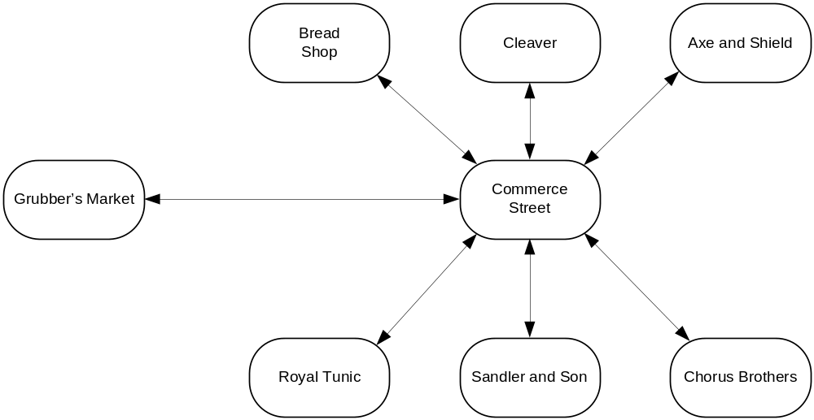

Rundown
Jack has opportunities to talk to people about the environment.

Baker

Butcher

Armory

Clothier

Jeweler

Moneylender

Notes
There isn’t much to this scene other than gathering information. The player can end the scene at anytime by going to find Bobby.
I’ve pasted the text I’d written in my original I7 file into some of the commands and descriptions. You may rewrite as you see fit.

Design
- Scene Begins when Jack enters Commerce Street for the first time.
- Commerce Street
  - Description: Shops are evenly spaced side by side on the narrow street including a bakery, butchery, armory, clothier, jeweler, and moneylender. Patrons and passersby walk along sidewalks, protecting them from the occasional teamster driving down the middle of the street. The street ends to the west at the Grubber's Market and extends east to the center of town.
  - [examine bakery] A sign above the store front has a picture of a loaf of bread. In the window you can see baguettes lined up and deeper in the store is a counter full of rolls and breads. The smell of deep fried dough wafts through the doorway, making your stomach growl.
  - [examine butchery] The sign above the butchery is a picture of a large pig. In the window you can see chickens, small pigs, hanks of beef, and other assorted meat dressed and ready for purchase. The smell of burning sausage masks the heavier smells of butchered animals.
  - [examine armory] An axe and shield can be seen hanging from a sign above the window, which frames an assortment of swords, rapiers, pikes, and helms.
  - [examine shops] The bakery, butchery, and armory are evenly spaced on the north side of Commerce Street while the clothier, jeweler, and moneylender shops line the south side.
  - [examine clothier] The exterior of the clothier's shop is trimmed in fine dark wood and in the window are a tunic and accessories that fit the current trends in fashion. As well, a finely made dress stalls next to the bodiless tunic and behind both is drapery, hiding the interior of the shop.
  - [examine jeweler] A sign above the store shows a necklace of pearls. The window is barred, but in a subtle way, and engraved with the name 'Sandler and Son'.
  - [examine lender] A discreet placard next to the door reads, 'Chorus Brothers', while the remainder of the windowless storefront is painted blue.
  - [examine space, look between shops] There are very narrow spaces between each of the six businesses.
  - [examine sidewalk] The brick sidewalks are raised slightly above the road with runoff drains marking each side.
  - [examine drains] The drain on the north side of the street is rusty and damaged. It's well known for pooling rainwater during a strong storm, while the drain on the south side of the street seems newly repaired and leaves a wide gap into the sewers below.
  - [examine north drain] The drain on the north side of the street is rusty and damaged. It's well known for pooling rainwater during a strong storm.
  - [examine south drain] The drain on the south side of the street seems newly repaired and leaves a wide gap into the sewers below.
  - [northwest] Move player to bakery.
  - [north] Move player to butchery.
  - [northeast] Move player to armory.
  - [southwest] Move player to clothier.
  - [south] Move player to jeweler.
  - [southeast] Move player to lender.
  - [down] Move player to sewer (1).
  - [east] Move player to Commerce East.
  - [go between bakery and butchery] Mention “You squeeze in between the two shops, barely...” and then move player to between bakery and butchery.
  - [go between butchery and armory] Mention “You squeeze in between the two shops, barely...” and then move player to between butchery and armory.

Chapter III – Bobby

Map
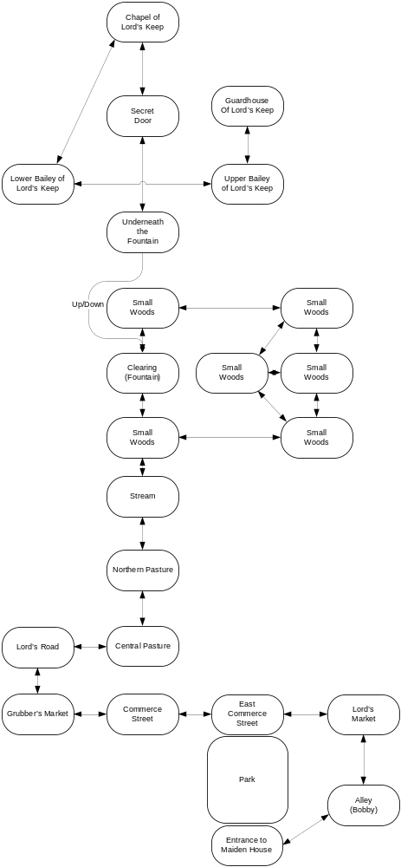

Rundown

Notes

Design

Chapter IV – Maiden House

Map
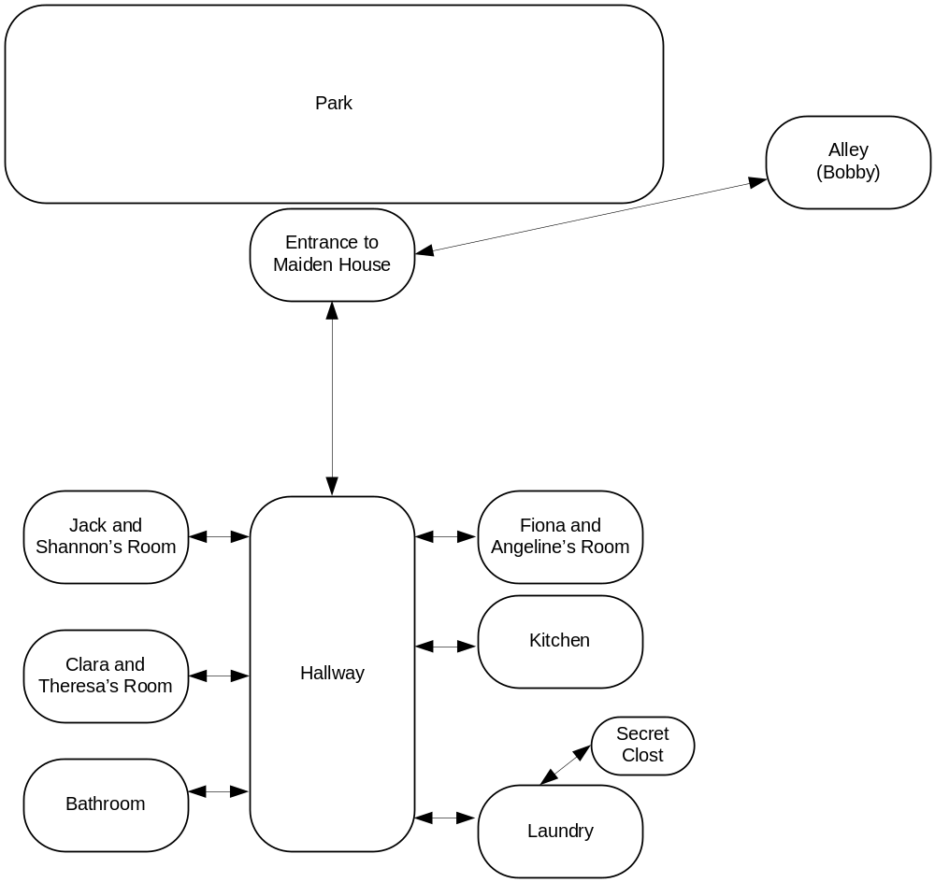

Rundown

Notes

Design

Chapter V – Captured

Map
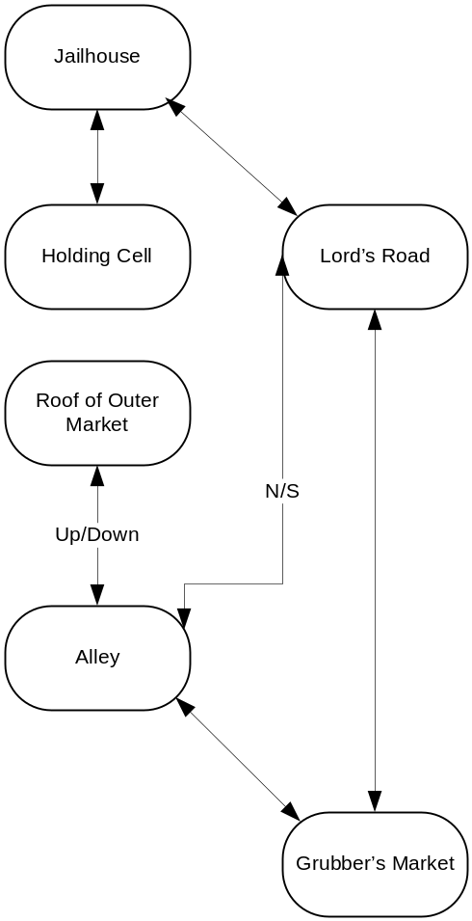

Rundown

Notes

Design

Chapter VI – Underground

Map
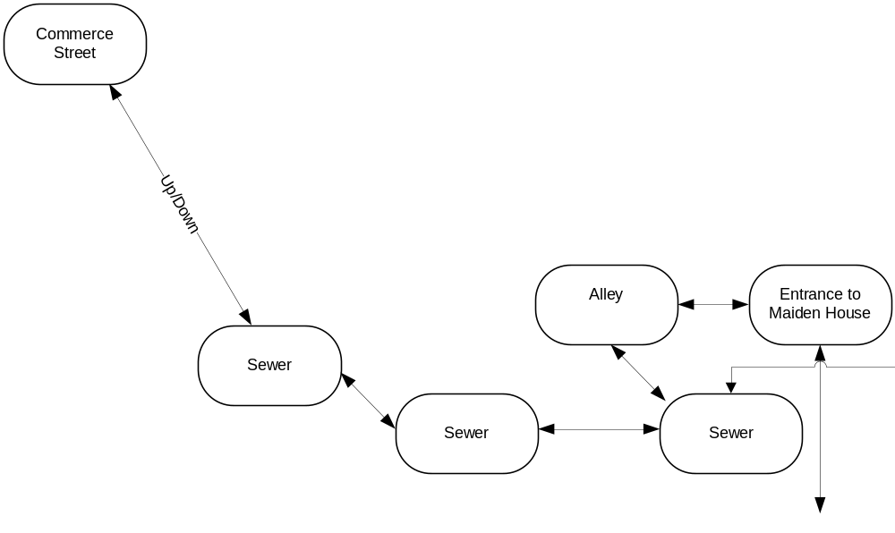

Rundown

Notes

Design

Chapter VII – Black Gate Estate

Map I - Rooftops
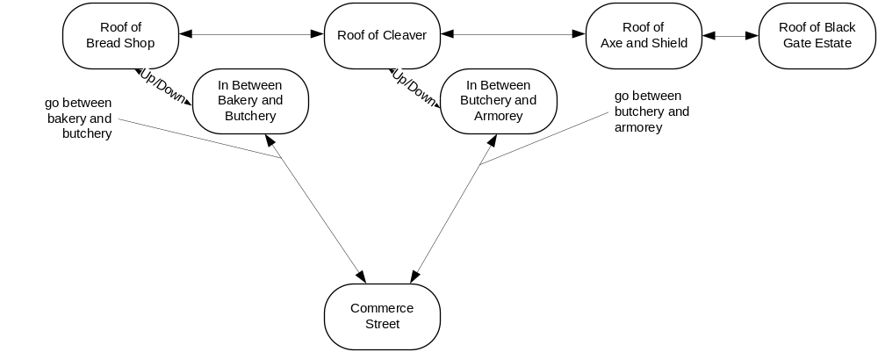

Map II – Black Gate Estate
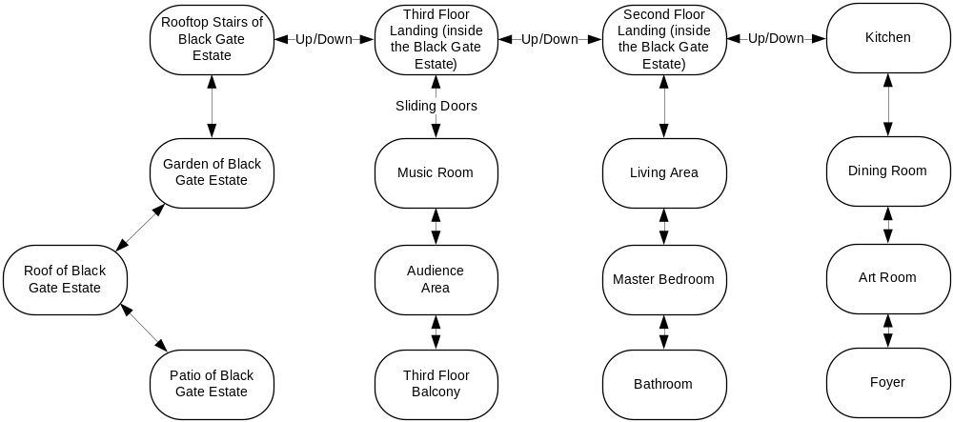

Rundown

Notes

Design

Chapter VIII – Maiden House II

Map

Rundown

Notes

Design

Chapter IX – Red Gate Estate

Map
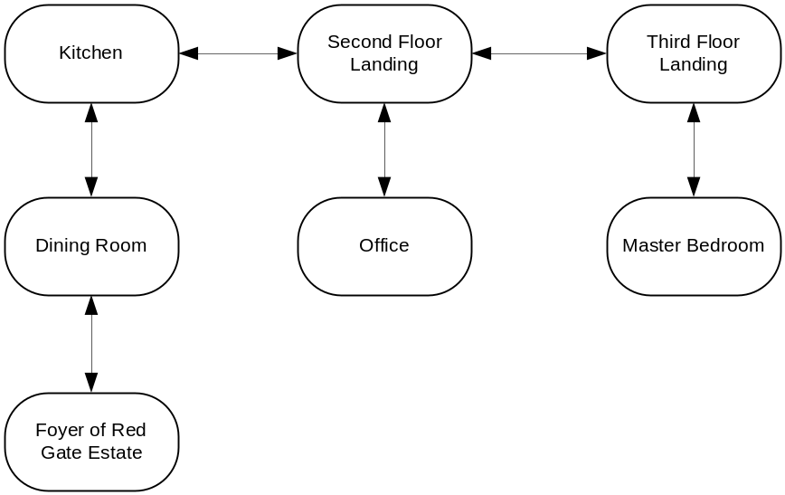

Rundown

Notes

Design

Chapter X – Pieter

Map
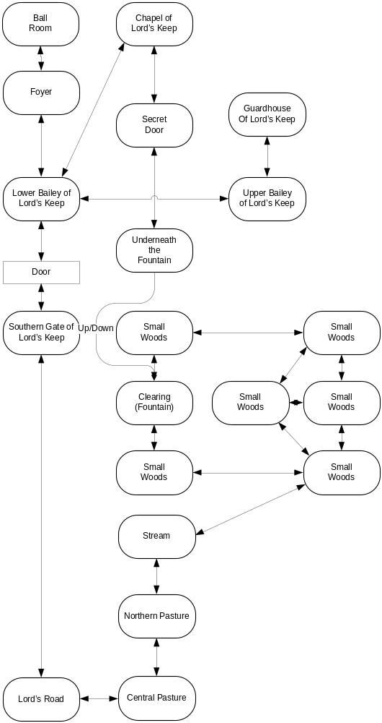

Rundown

Notes

Design

Chapter XI – Mercenaries

Map
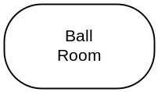

Rundown

Notes

Design

Chapter XII – The Baron

Map
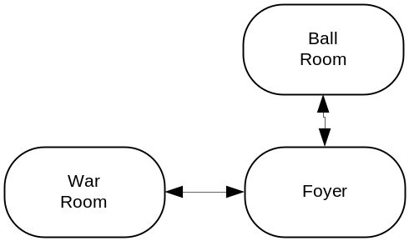

Rundown

Notes

Design

Chapter XIII – The War Room

Map
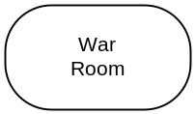

Rundown

Notes

Design

Chapter VIX – The Princess

Map

Rundown

Notes

Design

